Stakeholder Management Strategy
DOST STARBOOKS: Whiz Challenge

DOST Science and Technology Information Institute
Gen. Santos Ave., Upper Bicutan,
Taguig City, Metro Manila, 1631, Philippines

APRIL 2026

Table of Contents
1. Introduction 3
2. Identify Stakeholders 3
3. Key Stakeholders 4
4. Stakeholder Analysis 5

Introduction

This Stakeholder Management Strategy outlines the approach for identifying, analyzing, and managing stakeholders involved in the DOST STARBOOKS Whiz Challenge. Effective stakeholder management is essential to ensure project success by gaining support, minimizing resistance, and aligning expectations among all involved parties.

This strategy will be used to:

- Identify and classify project stakeholders
- Assess stakeholder power, interest, and influence
- Define appropriate communication and engagement approaches

Early and consistent stakeholder engagement is critical to the success of the project. The Whiz Challenge introduces a gamified system that may affect how users interact with STARBOOKS, requiring proper alignment of expectations among users, administrators, and partner institutions.

By proactively managing stakeholders, the project team aims to:

- Maximize engagement and adoption
- Address concerns early
- Ensure availability of resources and support
- Minimize risks related to resistance or miscommunication

Identify Stakeholders

The project team will conduct structured brainstorming sessions to identify all stakeholders associated with the Whiz Challenge. These sessions will include the project team, advisors, and representatives from the Department of Science and Technology (DOST).

Stakeholder Identification Approach

The process will be divided into:
- Internal Stakeholders – Project team, advisers, DOST-STII team
- External Stakeholders – Students, visitors, educators, partner institutions

Stakeholder Identification Criteria
An individual or group will be considered a stakeholder if they meet one or more of the following:
- Directly or indirectly affected by the system
- Has influence over project decisions or outcomes
- Impacts project resources (technical, financial, or operational)
- Possesses expertise required for the project
- Benefits from or may resist the system implementation

All identified stakeholders will be grouped logically (e.g., students, administrators, educators) to streamline communication and management.

Key Stakeholders

Key stakeholders are those with high influence, high interest, or significant impact on the project’s success.

Identified Key Stakeholders
- DOST-STII Representatives / STARBOOKS Team
- School Administrators and Facilitators
- Students
- Event/Exhibit visitors
- Project Development Team

Management Approach
The Project Manager will:
- Gather stakeholder expectations and concerns
- Determine preferred communication methods and frequency
- Involve key stakeholders in major decisions, testing, and feedback cycles

Key stakeholders may participate in:
- System testing and validation
- Feedback sessions and usability reviews
- Progress meetings and milestone evaluations

Continuous engagement ensures alignment with project goals and user needs.

Stakeholder Analysis

This section describes how the project team will analyze its list of identified stakeholders for the DOST STARBOOKS Whiz Challenge. This discussion includes how stakeholders will be categorized or grouped as well as the level of impact they may have based on their power, influence, and involvement in the project. Various tools and techniques will be used to quantify stakeholders and determine appropriate engagement strategies.

Once all Whiz Challenge project stakeholders have been identified, the project team will categorize and analyze each stakeholder. The purpose of this analysis is to determine the stakeholders’ level of power or influence, plan the management approach for each stakeholder, and determine the appropriate levels of communication and participation each stakeholder will have throughout the project.
The project team will categorize stakeholders based on their organization or role, such as users, administrators, technical teams, and partner institutions. Once all stakeholders have been categorized, the project team will utilize a power/interest matrix to illustrate the potential impact each stakeholder may have on the project. Based on this analysis, the project team will also complete a stakeholder analysis matrix which illustrates the concerns, level of involvement, and management strategy for each stakeholder.

The chart below will be used to establish stakeholders and their levels of power and interest for use on the power/interest chart as part of the stakeholder analysis.

Key | Organization | Name | Power (1-5) | Interest (1-5)
A | Students | A. End Users | 2 | 5
B | Department of Science and Technology / STARBOOKS | B. Program Management | 5 | 5
C | Educators | C. Teachers/Facilitators | 3 | 4
D | School Administration | D. School Heads/Admins | 4 | 4
E | Project Team | E. Developers | 5 | 5
F | IT Support | F. Technical Staff | 4 | 2
G | Partner Institutions | G. External Partners | 2 | 2

Below is the power/interest chart for the stakeholders. Each letter represents a stakeholder in accordance with the key in the chart above.
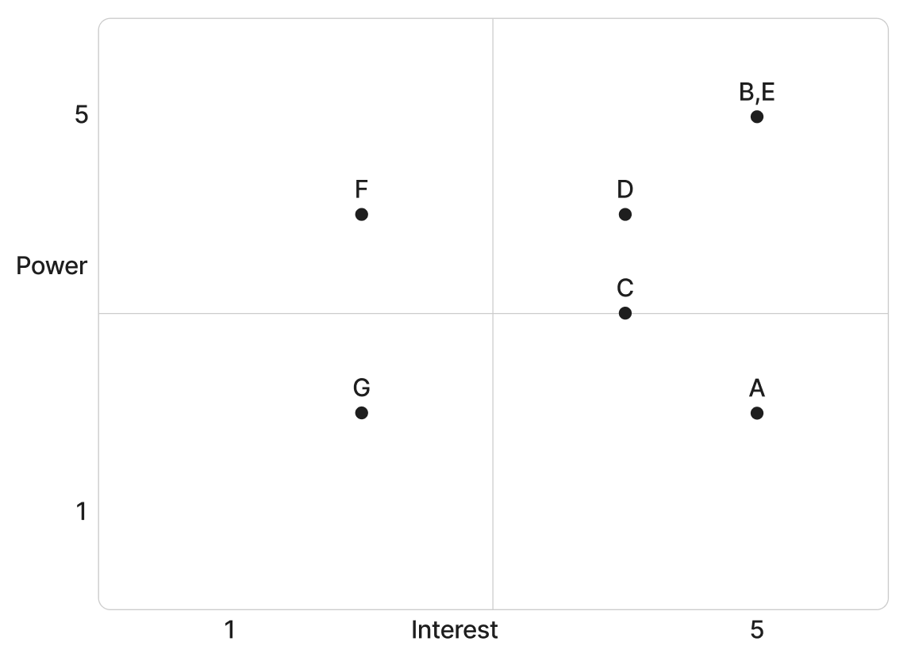
Based on the power and interest analysis and chart above, stakeholders G will require minimal management effort as they reside in the lower left quadrant of the matrix. Stakeholder F, in the upper left quadrant, must be kept satisfied by ensuring concerns and technical requirements are addressed adequately. Stakeholder A, in the lower right quadrant, must be kept informed through frequent communication, user support, and system updates. Stakeholders B, C, D, and E, in the upper right quadrant, are key players and must be involved in all levels of project planning and change management. Additionally, these stakeholders should be participatory members in project status meetings, testing phases, and milestone reviews as required.

The stakeholder analysis matrix will be used to capture stakeholder concerns, level of involvement, and management strategy based on the stakeholder analysis and power/interest matrix above. The stakeholder analysis matrix will be reviewed and updated throughout the project’s duration in order to capture any new concerns or stakeholder management strategy efforts.

Stakeholder | Concerns | Quadrant | Strategy
A | Ease of use, engagement, rewards | Keep Informed | Provide user-friendly interface, tutorials, and regular updates
B | Adoption rate, system effectiveness | Key Player | Involve in decision-making, provide frequent reports and updates
C | Integration into teaching activities | Key Player | Provide training, gather feedback, and ensure usability
D | Implementation and monitoring | Key Player | Share analytics dashboards and progress reports
E | System performance and deadlines | Key Player | Conduct regular meetings and agile coordination
F | Technical maintenance and workload | Keep Satisfied | Provide documentation and early communication of requirements
G | Awareness and participation | Minimal Effort | Provide occasional updates and outreach efforts

Sponsor Acceptance

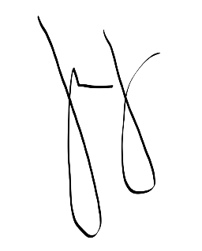
Approved by the Project Sponsor:

Date: April 8, 2026
Marievic V. Narquita
Information Services Section (ISS) Head of DOST-STII

